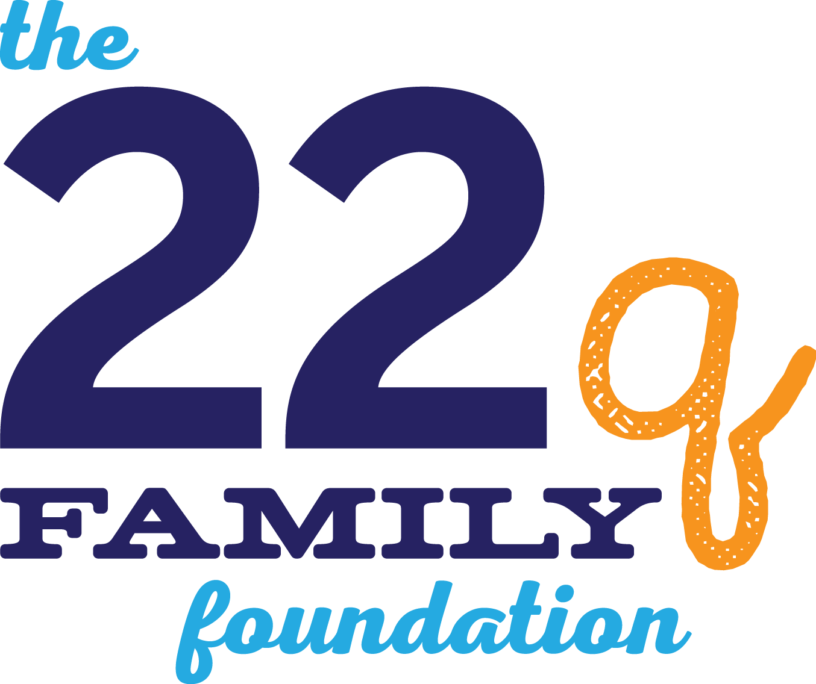

To Whom It May Concern,

November is 22q11.2 Deletion Syndrome Awareness Month, and I am writing this letter to you on behalf of The 22q Family Foundation. As you may or may not know, someone close to me was born with 22q and I am making it my mission to do what I can to positively impact the lives of them and many others. The 22q Family Foundation is a national 501c(3) non-profit that raises awareness for 22q while connecting, supporting, and offering accurate information to families affected by this syndrome. They provide free educational support for families to lessen the burden that many of us face having a medically complex child/young adult. This includes access to educational consulting to support the unique learning needs my loved one has, access to a career coach to assist with helping design transition plans into adulthood, and the opportunity to apply to scholarships that are designated for students with 22q.

22q deletion syndrome very often affects all systems of the affected person’s body. There are around 200 symptoms visible and invisible with common symptoms including:
-speech delay
-heart defects
-health and developmental delays
-breathing problems
-gastrointestinal issues
-immune and endocrine system issues
-learning difficulties in school

Early diagnosis is key to helping individuals affected by the disorder get the most help possible! We want to make 22q a household name and need your help now. During the month of November, would you consider committing to either financially sponsor a social media post or match donations received by the foundations for one day (with or without a cap)? Your financial gift will help families like mine continue to receive educational support. With your help, they can continue their efforts to make everyone aware of 22q11.2 deletion syndrome and help keep their services FREE for all families. When you commit to helping for a day in November, The 22q Family Foundation is committed to helping support your business. When you help spread awareness through your employees, community and network, The 22q Family Foundation will spread the word of your company’s generosity on a website that gets thousands of views per day, as well social media posts that go out to 16,000+ followers.

To commit to giving a financial gift in November, please contact Lindsey Garcia, Executive Director of the 22q Family Foundation at 831-200-4227 or info@22qfamilyfoundation.org.

Sincerely,

(your name)

